# How to import WebPlay project into IntelliJ

## Import the WebPlay project

1. Find the installation folder of the Play framework (and go there)
2. cmd
3. activator ui
4. Browse to the WebPlay project, open it, etc
5. In the „Code” section, click the settings icon (cogwheel), then „Open… IntelliJ”  
   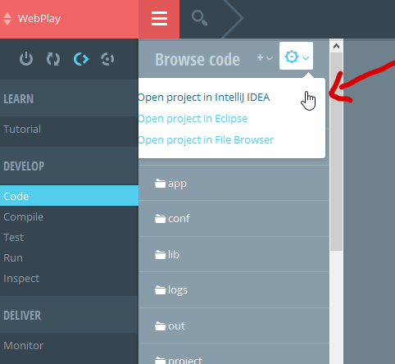
6. (Re)generate the project files.
   1. (Comment: I also had to do this when moved the project [the entire eclipse workspace] to somewhere. Strange but after this the IntelliJ could not open the project [some error referencing to eclipse; first it was a reused eclipse project])
   2. If there is any error during this, try to recompile the project; then restart activator ui; then try again this step.
7. Open the project in IntelliJ

## Import the dependencies

1. File/Import module 🡪 browse the ServiceClientProxy’s location  
   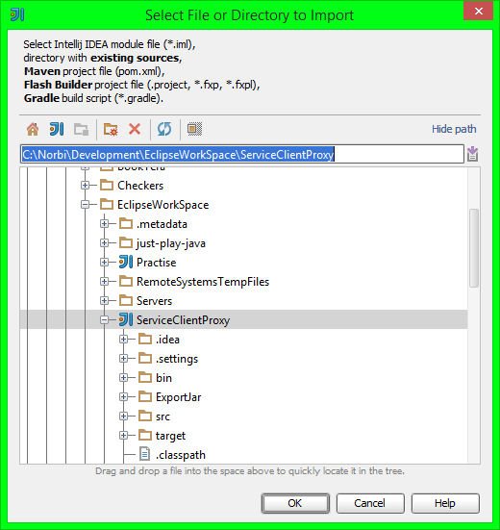
2. Import module as Maven
3. Set up next step like this:  
   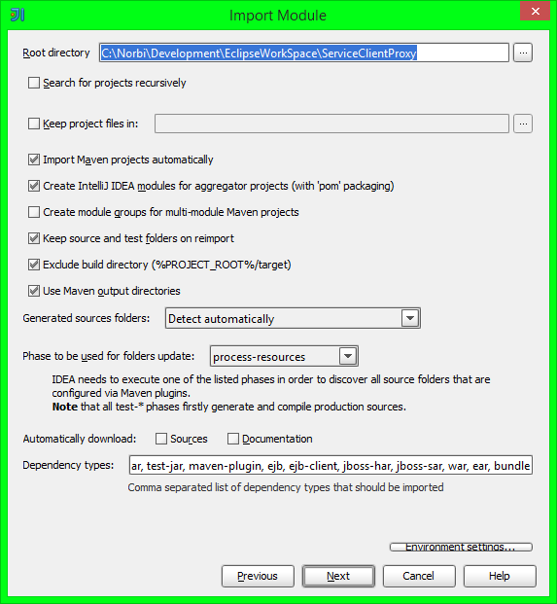
4. Select the single Maven project to import, then click Finish

## Other necessary inits

1. File/Project Structure
   1. Project tab 🡪 The SDK and the level are Java 8
   2. Modules tab 🡪 Check that all modules have Java 8 (or project set) as level and sdk (sources and dependencies tabs)
2. File/Settings/Compiler/Java Compiler
   1. The „project bytecode version” field here should be „JDK default” (=empty). If the „per-module bytecode version” list is not empty, delete its items.